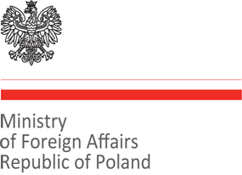 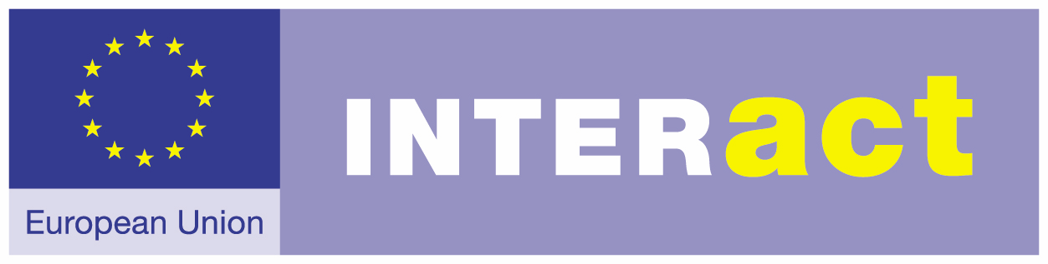 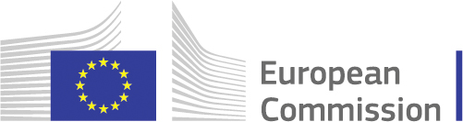

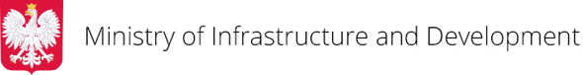

**INVITATION**

**The Ministry of Foreign Affairs of Poland, acting as the current Chair of the EU Strategy for the Baltic Sea Region, and the Ministry of Infrastructure and Development of Poland in partnership with the European Commission and INTERACT**

**have the pleasure to cordially invite you to**

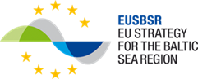

**EU Strategy for the Baltic Sea Region Seminar**

**POSITIVE CHANGE IN THE BALTIC SEA REGION**

How far have we gone and why do we want to go on?

10 December 2015, Warsaw, Poland

Venue: Ministry of Infrastructure and Development[1]

Wspólna 2/4 Street

This one day seminar (8.30 – 18.00) is looking for best ways of cooperation in the Baltic Sea Region using the potential of **the European Union Strategy for the Baltic Sea Region**.

We will look into and discuss:

* the concrete examples of what we have already achieved with the EUSBSR and what our ambitions are for the future
* the best ways of making our achievements work on the policy level
* how to communicate and show benefits it provides for countries involved and ordinary people in the region
* how to enhance support to the EUSBSR by the European Structural and Investment Funds programmes, what are the bottlenecks and what solutions could be found to overcome those

The seminar is meant to bring together the **current EUSBSR stakeholders** (European Commission, EUSBSR National Coordinators, Policy Area and Horizontal Action Coordinators, Flagship Leaders and cooperating partners, INTERACT, Interreg Baltic Sea Region programme, Focal Points) and **potential new players** interested to join in as well as **European Structural and Investment Funds programme managers**. Number of participants: up to 150.

**Please register by filling in the table below and sending it back to** [joanna.wojtkowska@msz.gov.pl](mailto:joanna.wojtkowska@msz.gov.pl) and [agnieszka.marszalek@msz.gov.pl](mailto:agnieszka.marszalek@msz.gov.pl) **by 3 December.** **Please do not finalize your travel or accommodation arrangements prior to having received a confirmation of successful registration.**

|  |  |  |  |  |  |  |
| --- | --- | --- | --- | --- | --- | --- |
| **Name and surname** | **Country** | **Institution** | **Relation to the EUSBSR** (are you National Coordinator, Policy Area/Horizontal Action Coordinator, Flagship Leader, Partner in a Flagship, Managing Authority, Focal Point, institution interested to start cooperation within the EUSBSR, other?) | **E-mail** | **Telephone** | **Dietary restrictions** |
|  |  |  |  |  |  |  |

**DRAFT PROGRAMME**

|  |  |
| --- | --- |
| **8:30 – 9:00** | **Registration**  **Welcoming coffee** |
| **9:00 – 9:10** | **Opening of the seminar**  ***Jerzy Kwieciński***, Secretary of State, Ministry of Infrastructure and Development, Poland  ***Katarzyna Kacperczyk***, Undersecretary of State, Ministry of Foreign Affairs, Poland  ***Peter Schenk***, European Commission Directorate-General for Regional and Urban Policy |
| **9:10 – 11.00** | **The EU Strategy for the Baltic Sea Region and its achievements: What is the recipe for success? How to ensure sustainability of results?**  *In this panel we will show concrete examples of our achievements and ambitions for the future as well as the fate of the Flagships. We will discuss the added value of the EUSBSR and try to identify success factors for maximizing and sustaining results as well as the best ways of making our achievements work on the policy level.*  *Lead: PL MFA and DG REGIO, suggestions from the NC, support IBSR*  ***AGENDA:***  **Positive change in the Baltic Sea Region - examples**:  ***BaltPrevResilience*** (10 minutes) – the goal is to prevent and reduce the consequences of everyday accidents and disasters or crises. A key element in the accident prevention and consequence reduction is improved learning from accidents and disasters, preferably already from minor every day accidents (PA Secure).  Presented by: ***Rainar All***, Swedish Civil Contingencies Agency  ***Assessment of regional nutrient pollution load and identification of priority projects to reduce nutrient inputs from Belarus to the Baltic Sea*** (10 minutes) – the aim of the project was to identify priority investments and build local capacity in the reduction of nutrient inputs to the Baltic Sea. The project identified cost efficient ways to reduce Belarusian discharges of nutrients to the Baltic Sea and selected a priority list of 10 waste water treatment plants and one poultry farm for investments (PA Nutri).  Presented by: ***Anja Nystén***, Nordic Environment Finance Corporation (NEFCO), Finland  ***Baltic Sea Tourism Center*** (BSTC) (10 minutes) – the main objective of the project is to set up sustainable structures for improved tourism communication and cooperation on transnational level in the Baltic Sea Region facilitated by a permanent service unit. This unit – called Baltic Sea Tourism Center - associates the key tourism stakeholders and promotes sustainable, responsible and innovative tourism in the Baltic Sea region. The BSTC should act as a B2B information and coordination center and serve as a first contact point for tourism organizations, companies and further stakeholders - within and beyond the Baltic Sea region. The BSTC directly fosters the implementation of the EUSBSR. It fills the missing link between the strategic and political cooperation in the Baltic Sea region and the private sector.  Presented by: ***Johannes Volkmar***, Mecklenburg-Vorpommern Tourist Board, Germany  ***Ecovillages for sustainable rural development*** (10 minutes) – the overall objective of the project was to develop more sustainable ways of living in rural areas of the BSR by offering a toolkit for ecovillage initiators and developers of various technological and social eco-initiatives. Project have created informal education system on eco-technologies and nature-friendly living models within BSR region based on Ecovillage Movement experiences and produced training materials with case studies of best practice examples from BSR. Recommendations for policy-makers resulting by project activities on new rural development measures helped to find innovative ways to increase sustainability of rural areas within BSR.  Presented by: ***dr.*** ***Zivile Gedminaite-Raudone***, Lithuanian Institute of Agrarian Economics  ***SUBMARINER Network*** *and* ***PartiSEApate*** (10 minutes)  *The SUBMARINER* ***Network*** is a unique platform that brings actors from the whole Baltic Sea Region together to actively promote innovative and sustainable uses of marine resources. It operates across the whole knowledge triangle integrating perspectives from local to international scale, different science disciplines as well as policy and economic stakeholders. The network is registered as a not-for-profit European Economic Interest Grouping (EEIG) and is managed by a professional secretariat.  The overarching ambition of the *PartiSEApate*project was to develop a MSP Governance Model. Representatives from different sectors (aquaculture, shipping & ports, nature conservation & environment, fishery, offshore wind energy, underwater cultural heritage, climate change, research and data network building) were invited to discuss MSP-related issues relevant to their sector in the Baltic Sea. In the course of the PartiSEApate project,  instruments for multi-level MSP were developed and tested in three pilot cases. The Handbook on Transnational Consultation was produced.  Presented by: ***Joanna Przedrzymirska****,* Head of the Project Management Centre, The Maritime Institute in Gdansk, Poland  ***BEMIP and EUSBSR PA Energy Reform*** (10 minutes) - Remarkable changes are made by bringing together two initiatives for regional cooperation - Baltic Energy Market Interconnection Plan (BEMIP) and EUSBSR Policy Area (PA) Energy in order to improve the macro regional cooperation in the energy sector. During the Latvian Presidency of the Council of the EU the existing regional cooperation framework in the Baltic Sea Region was reformed. An agreement on Memorandum of Understanding on the reinforced BEMIP and revised Action Plan for EUSBSR PA Energy – BEMIP was reached among the representatives of Denmark, Germany, Estonia, Latvia, Lithuania, Poland, Finland, Sweden and Norway (as an observer). Later the MoU was signed by the Baltic Sea region energy ministers and the Commissioner for Climate Action and Energy.  PA Energy – BEMIP Action Plan for competitive, secure and sustainable energy is now part of the overall revised EUSBSR Action Plan.  Presented by: ***Dzintars Kauliņš***, Ministry of Economics of Latvia, Policy Area Co-coordinator of PA Energy  ***Panel discussion & Questions and answers*** (50 minutes)  ***Participants of the panel:***  ***Susanne Scherrer,*** Director of the Managing Authority and the Joint Secretariat of the Interreg Baltic Sea Region programme  ***Rainar All***, Swedish Civil Contingencies Agency  ***Anja Nystén***, Nordic Environment Finance Corporation (NEFCO), Finland  ***Johannes Volkmar***, Mecklenburg-Vorpommern Tourist Board, Germany  ***Zivile Gedminaite-Raudone***, PhD., Lithuanian Institute of Agrarian Economics  ***Joanna Przedrzymirska****,* Head of the Project Management Centre, The Maritime Institute in Gdansk, Poland  ***Dzintars Kauliņš***, Ministry of Economics of Latvia, Policy Area Co-coordinator of PA Energy  *Moderator:* ***Peter Schenk****,* European Commission Directorate-General for Regional and Urban Policy  *During panel discussion and discussion with the audience we will try to answer the following questions:*   * *What is needed to reach a success in the EUSBR?* * *How to make sure your project brings desired impact?* * *What was the biggest success of the project?* * *What happens to the completed Flagships? Did the project manage to develop ‘a life after life’? Is it sustainable, i.e. does it have a follow-up? Does it have any recommendations that were taken to the policy level? How was it achieved? Or why wasn’t it successful in reaching the policy level?* * *Possible reaction from the PACs related to the presented Flagships: how the projects relate to your policy area context, what is their role?* * *Apart from projects what are the other achievements of the EUSBSR?* |
| **11:00 – 11:30** | **Coffee break** |
| **11:30 – 13:00** | **Communicating the EUSBSR: How to reach out and promote our achievements? How to attract newcomers and improve internal communication and knowledge exchange?**  *In this panel we will discuss how to best communicate about the EU Strategy for the BSR and show benefits it provides for countries involved and ordinary people in the region. We will also pay attention to enhancing information exchange among present EUSBSR stakeholders. We will present the Communication Strategy of the EUSBSR.*  *Lead: INTERACT and PL MFA*  ***AGENDA:***  **The Communication Strategy of the EUSBSR** - ***Ulf Wikström***, INTERACT  **Sharing of experience/good practice of communication efforts (panel discussion):**  National level – ***Erja Tikka***, National Coordinator for the EUSBSR, Finland  Policy Area/Horizontal Action Coordinator level – ***Anders Bergström***, Norden Association, Sweden, Co-coordinator of Horizontal Action Capacity and Policy Area Education  ***Eeva Rantama,*** Interreg Baltic Sea Region Managing Authority/Joint Secretariat  **Baltic Sea Network – European Social Fund** – ***Paweł Szymański***, ESF Department, Ministry of Infrastructure and Development, Poland  *Moderator:* ***Ulf Wikström****, INTERACT*  ***Questions and answers*** |
| **13:00 – 14:30** | **lunch** |
| **14:30 – 17:00** | **Cooperation and coordination across programmes in the Baltic Sea region: How to better implement the EUSBSR?**  *This panel will discuss what needs to be done for more efficient financial support to the EUSBSR implementation by the ESIF programmes.*  *Aim: Panel is aiming at discussing among invited speakers and seminar participants not only on the gaps that need to be addressed but also will focus on defining concrete actions and identifying possible solutions for closer coordination among ESIF programmes in the Region.*  *It is planed that the panel will present good practice examples and suggestions for further cooperation.*  **Focus on during the session (agenda):**   1. presentation of conclusions of the study ‘Cooperation methods and tools applied by the European Structural and Investment Funds to support implementation of the EUSBSR’ (INTERACT, 2015) (Study) (expert doing the Study); 2. practice challenges for the ESIF programmes when providing support to the EUSBSR (programme and project level) (Ministry of Infrastructure and Development, Poland, Swedish Agency for Economic and Regional Growth (Tillväxtverket) and Managing Authority of Pomorskie Region); 3. and experiences from other macro-regions on embedding question (Directorate-General for Regional and Urban Policy, European Commission).   **Expected outcome of the panel:**   1. list common issues faced by the ESIF programmes that need to be addressed at the Baltic Sea region level in the months to come; 2. get general agreement from the panel and audience if there is a need for a change and at least mention some of further possible actions that could be taken by actors (ESIF programmes, PACs/HACs, National Coordinators, DG REGIO) to embed the EUSBSR stronger into the ESIF programmes. The discussion on ‘how’ the ‘embedding process’ could be supported will be discussed at the meeting of National Coordinators for the EUSBSR, 11 December 2015   **Speakers:**  ***Pertti Hermannek***, PH - Projektmanagement & Beratung, co-author of the study ‘Cooperation methods and tools applied by the European Structural and Investment Funds to support implementation of the EUSBSR’, INTERACT, 2015;  ***Vicente Rodriguez-Saez***, European Commission Directorate-General for Regional and Urban Policy;  ***Piotr Zygadło***, Ministry of Infrastructure and Development, Poland;  ***Tommy Anjevall***, Swedish Agency for Economic and Regional Growth (Tillväxtverket);  ***Radomir Matczak***, Managing Authority of Pomorskie Region.  *Moderator***: *Baiba Liepa***, INTERACT |
| **17:00 – 17:15** | **coffee break** |
| **17:15 – 17:45** | **7th EUSBSR Forum in Stockholm**  ***Erik Kiesow*,** National Coordinator for the EUSBSR, Sweden |
| **17:45** | **End of Seminar** |

Please find the map with the seminar venue (red mark):

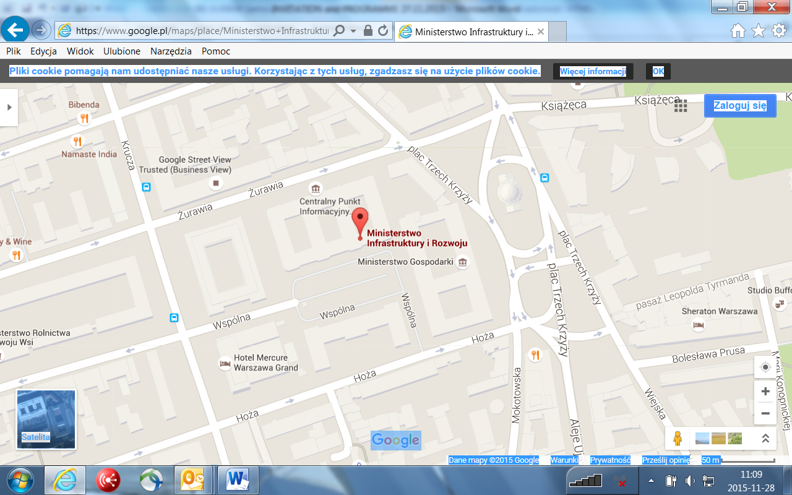

1. See the map on page 7.